**Observation records**

**Purpose**

The purpose of observation is to investigate the current situation of accessibility facilities(especially for the blind and visually impaired groups). Since I am not one of the people who need them, so I can ignore most of them during daily life.

**Observation Site**

The observation was taken in two sites located in Beijing China.

1. Subway stations

Subway stations have a high volume of people, which may include those who need accessibility facilities, the purpose of choosing these sites is to observe the general setting and usage of accessibility facilities

1. Streets near Eye hospitals

There is probably no other place to see more patients than at a hospital, and streets near an Eye hospital probably is the place where you will see the most visually impaired people. Choosing streets near the Eye hospital and not inside the hospital because the Eye hospital might have some special set-ups for the visually impaired groups, and what I want to learn is their situation of them in real life.

**Observation Records**

1. 2 Subway stations

**Time:** A Saturday afternoon

**Time frame:** 2 hours

**Weather:** cloudy

**Observation position:** The observer (I) was wandering around the subway station, activities including sitting on a bench in a subway station next to an escalator, and walking around the subway station.

**Observation raw notes:**

It was correct to choose a Saturday afternoon, there are more causal travellers than on weekdays, parents are taking their kids to a place for fun (I guess), there are travellers carrying baggage to a train station maybe, people are going to work or leaving from the workplace (because they are wearing suits), and there are people just looking to transport. For privacy reasons, I am not taking any photos or videos, but just writing about the phenomena and insights I see and think are important to my research purpose.

1. There are escalators and elevators in most of the subway stations.
2. The volume of people in the subway station is pretty high as I expected.
3. If there are no escalators or elevators, there would be an auxiliary facility installed on the staircases shown in the picture below (was not taken by the observer)

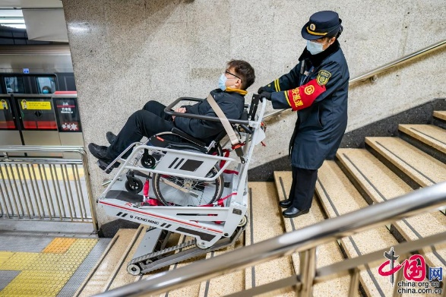(Figure 1)

1. Ramps can be placed for wheels to board the subway shown in the picture below (was not taken by the observer)

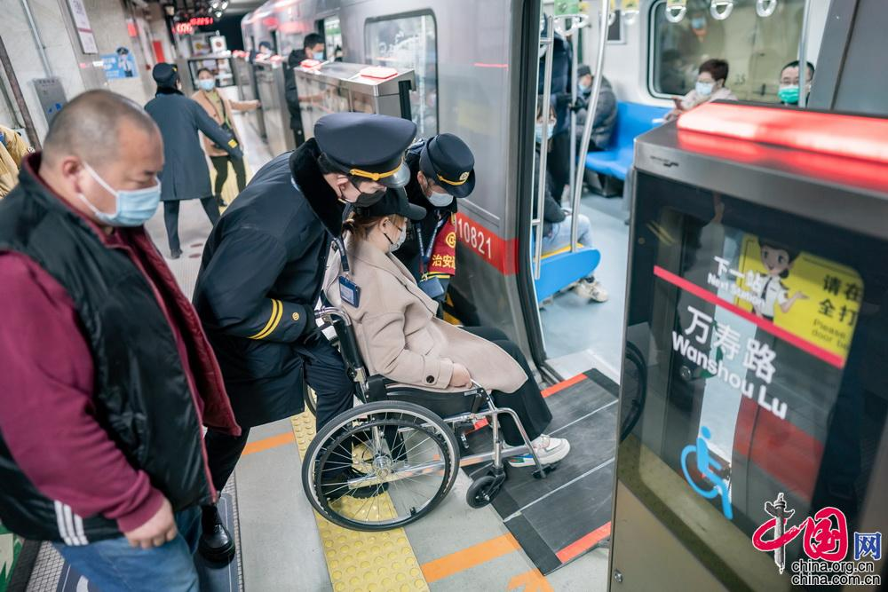(Figure 2)

1. Guides are available at subway stations
2. A volunteer is helping a traveller move the baggage
3. There are AEDs installed in the subway stations

**Conclusion**

This observation did not seem to capture any visually impaired groups, but I think the accessibility facilities and services inside the subway station could somehow help a blind person if it is in need.

1. **Streets near an Eye Hospital**

**Time:** Sunday morning

**Time frame:** 2 hours

**Weather:** Cloudy

**Observation position:** Sidewalk near the crossroads

**Observation raw notes:**

Did not get lucky last time in the subway stations last time has led me to rethink the observation site, then I came up with the Eye hospital where the place you probably can see the most visually impaired people. I am now standing on the sidewalk near a crossroads, hopefully, I will see more visually impaired people this time. Did not get lucky last time in the subway stations last time has led me to rethink the observation site, then I came up with the Eye hospital where the place you probably can see the most visually impaired people. Like last time I will record the phenomena and insights I see and think are important to my research purpose.

1. The volume of general people is also pretty high, this might be because of the place of the hospital, which is near downtown.
2. I can see some patients going in and out of the hospital, but most of them do not seem to have too many issues with their eyes (not affecting their daily lives)
3. An elderly person with a visual disability is being helped (by her family member I guess) to walk on the sidewalk
4. There are cars and well covers blocking the blind alley
5. Some patients came here by car, and they head straight back to their cars after they come out of the hospital. So, it is hard to observe how they fit in the reality.
6. Finally, one blind man is walking with a blind stick. The blind stick is old-fashioned with red and white strips. His behaviour looks professional, he might have been blind for a long time.

**Conclusion:**

Luckily, I have been able to observe the behaviour of some blind and visually impaired people today, most of them still cannot walk or live all by themselves, and need external help such as a family member, unless they are super professional with what they are doing, but still, their lives alone are limited.

BTW, I do not see any guide dog today, as I expected to see at least one.

Reference

[1] Figure 1

郑 亮 (no date) 助力冬残奥​提升无障碍服务品质 北京地铁公司提供暖心服务[组图], 助力冬残奥​提升无障碍服务品质 北京地铁公司提供暖心服务[组图] _ 图片中国_中国网. Available at: <http://photo.china.com.cn/2022-03/01/content_78078325.htm>.

[2] Figure 2

郑 亮 (no date) 助力冬残奥​提升无障碍服务品质 北京地铁公司提供暖心服务[组图], 助力冬残奥​提升无障碍服务品质 北京地铁公司提供暖心服务[组图] _ 图片中国_中国网. Available at: <http://photo.china.com.cn/2022-03/01/content_78078325.htm>.